Name: Amin Ur Rashid
Class: BESE-5B
Reg No. 111697
Lab 11

Introduction:
In this lab we were given the task of installing hadoop by following some steps and then using it to execute the MR report. The other task was to configure the single node cluster and to be able to count the word frequency in any given file using Map reduce job.

Configuration and Installation Steps:

For installation I followed the following two links:
1) https://xuri.me/2015/03/09/setup-hadoop-on-ubuntu-single-node-cluster.html
2) https://hadoop.apache.org/docs/stable/hadoop-project-dist/hadoop-common/SingleCluster.html

Firstly I installed the requisite software using the commands:
$ sudo apt-get install ssh
$ sudo apt-get install rsync

I installed the hadoop package using the following command in the terminal:
- $ wget http://ftp.tc.edu.tw/pub/Apache/hadoop/common/hadoop-2.7.2/hadoop-2.7.2.tar.gz
Then I unpacked the downloaded package using the command given below in the terminal:
- $ sudo tar -xvzf hadoop-*.tar.gz -C /usr/local/ && sudo mv /usr/local/hadoop-* /usr/local/hadoop
Opened the bashrc file and added a few extra lines of code and then saved that specific file which can be seen using the screenshot below.
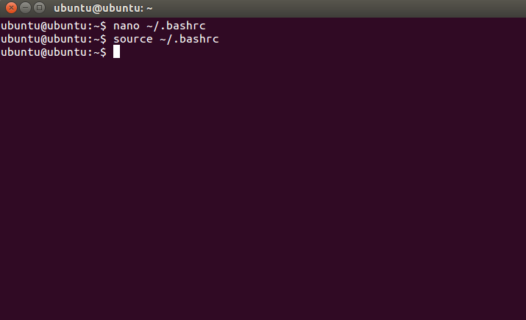
For Configuration the following site was used:
1) https://xuri.me/2015/03/09/setup-hadoop-on-ubuntu-single-node-cluster.html

Firstly changes were made in the file hadoop-env.sh and then the directory and their ownerships were assigned using the specific code provided in the link above.
Then to start the single node cluster we had to run the following command once we are in one of the directories:
- $ start-dfs.sh && start-yarn.sh
This will verify our managers and nodes in our machines and all these commands will lead to the end of the configuration.

